All Exercises to be done with no pain.
Can be done up to 2x day, or as directed by Dr.Trish.

Upper Trapezius Stretch

Sit on the edge of your bed or in a chair. Start with head in mid line and shoulders relaxed.


Lower your right shoulder or sit on your hand. Then, tilt your head away from the right shoulder and bringing your left ear towards left shoulder.
Hold for 20 seconds while keeping even breaths.

Return to mid line, repeat on same side 2 more times. Discomfort may occur; the goal of this stretch is a therapeutic discomfort ranging from 4-5 out of 10 pain scale.

Return to mid line, and repeat stretch 3x to opposite side 20 seconds each, keeping and even breath.
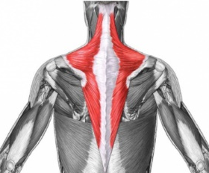

The Trapezius

