All Exercises to be done with no pain.
This exercise can be done starting at 1x a day before bed. Working to reach 2x per day, once in the morning when waking up, then in the evening before bed.
Or as directed by Dr.Trish.

Towel Roll Exercise

Start by lying on your bed flat on your back, with knees bent.
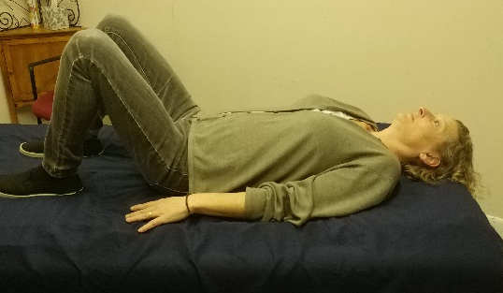

Take a rolled bath towel and place it beneath your neck in the natural curve of the cervical spine. Both head and shoulders will be raised off the bed, try to bring shoulders down to the bed.

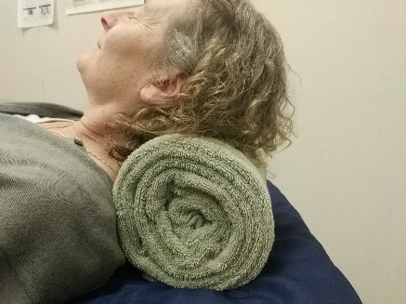

Rest in this position with slow even breaths for up to 15 minutes. If pain occurs usually in a burning sensation, remove towel and rest. Slowly work up to 15 minutes over the next two weeks.
(Note: It is normal to only be able to handle 2min when first starting this exercise.)
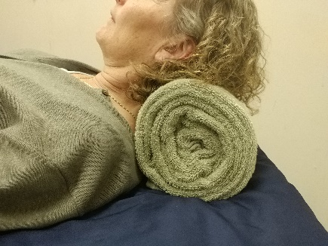

Best towel Rolling Method

Start with a thin bath towel as the exercise becomes more comfortable, slowly work up to a thicker towel.

Start with the towel vertical, fold each side into center.
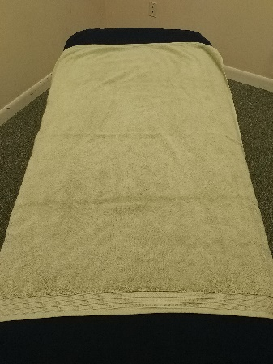

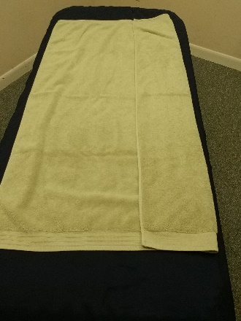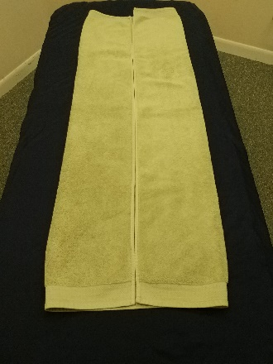

Fold along center to create a quarter fold.
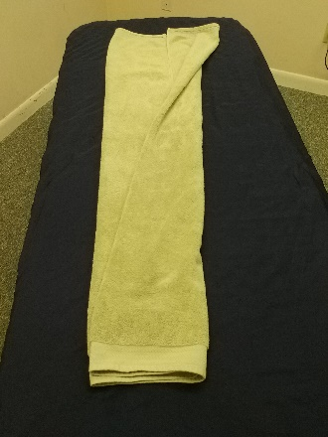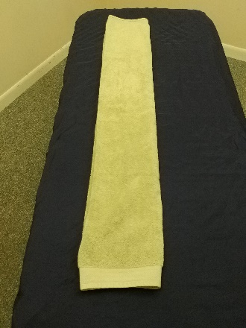

Roll the towel as tightly as you can.
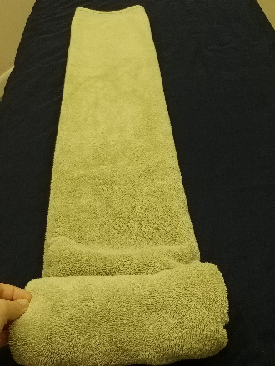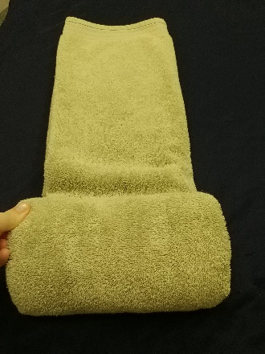

Use string or duct tape to hold the towel in a tight roll.
(We used rubber bands for the pictures)
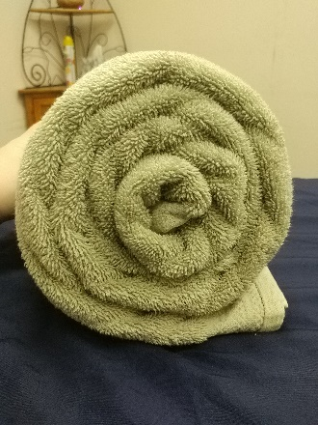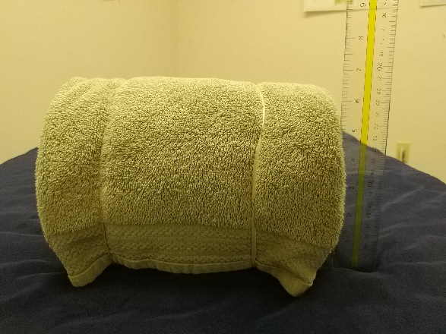
We used a thicker towel for pictures. You should not start at this thickness

Dr.Trish recommends keeping the towel roll on or by your bed for easy remembering.

