All Exercises to be done with no pain.
Stretch is most effective on a warm muscle, such as after a shower.
Can be done up to 2x day, or as directed by Dr.Trish.

Scalene Stretch

Lean or sit on the edge of your bed or a hard surface about waist height. Extend one arm to the side with your hand in a plank, fingertips resting on the surface.

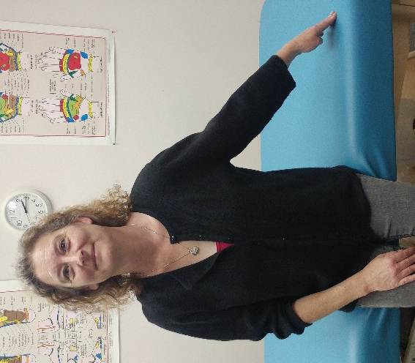

Tilt your head slightly away from extended arm while pressing fingertips into surface. You should feel a stretch in the muscles of your neck, sometimes extending past the shoulder into the arm.

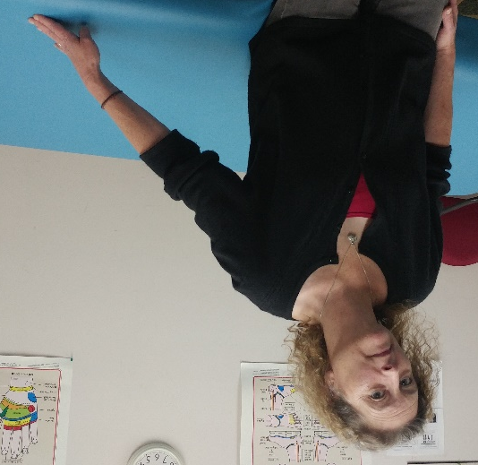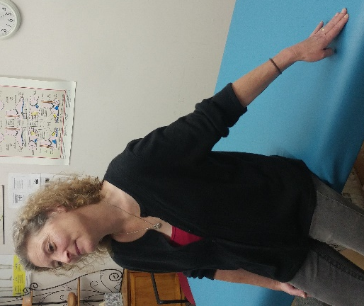

Hold position for 3 deep breaths (about 30 seconds). Return to starting position and repeat to the opposite side.

